Rongjin Dang (001565800)

**Program Structures & Algorithms**

**Fall 2021**

**Assignment No. 3**

* **Task (List down the tasks performed in the Assignment)**

**Step 1:**

**(a) Implement height-weighted Quick Union with Path Compression. For this, you will flesh out the class UF_HWQUPC. All you have to do is to fill in the sections marked with // TO BE IMPLEMENTED ... // ...END IMPLEMENTATION.**

**(b) Check that the unit tests for this class all work. You must show "green" test results in your submission (screenshot is OK).**

**Step 2:**

**Using your implementation of UF_HWQUPC, develop a UF ("union-find") client that takes an integer value n from the command line to determine the number of "sites." Then generates random pairs of integers between 0 and n-1, calling connected() to determine if they are connected and union() if not. Loop until all sites are connected then print the number of connections generated. Package your program as a static method count() that takes n as the argument and returns the number of connections; and a main() that takes n from the command line, calls count() and prints the returned value. If you prefer, you can create a main program that doesn't require any input and runs the experiment for a fixed set of n values. Show evidence of your run(s).**

**Step 3:**

**Determine the relationship between the number of objects (n) and the number of pairs (m) generated to accomplish this (i.e. to reduce the number of components from n to 1). Justify your conclusion in terms of your observations and what you think might be going on.**

* **Relationship Conclusion: (For ex : z = a * b)**

**The relationship between n and pair is linear**

* **Evidence to support the conclusion:**

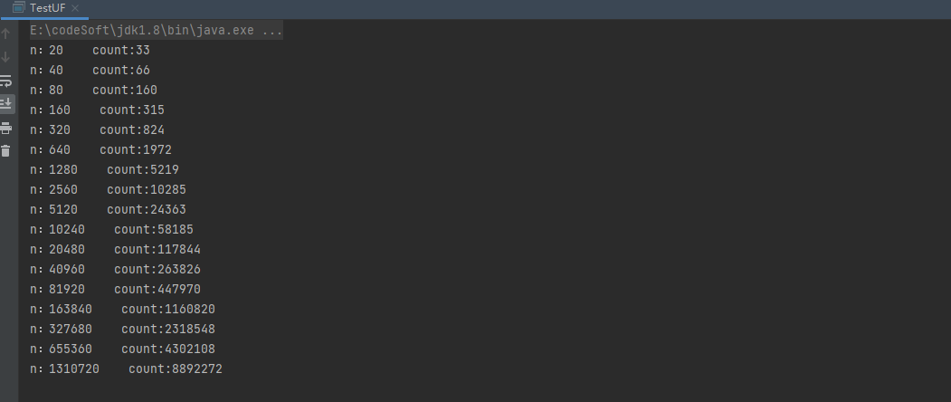

1. **Output (Snapshot of Code output in the terminal)**
2. **Graphical Representation(Observations from experiments should be tabulated and analyzed by plotting graphs(usually in excel) to arrive on the relationship conclusion)**

* **Unit tests result:(Snapshot of successful unit test run)**